SIMATS ENGINEERING
ASSESSMENT TOOL 2

COURSE NAME: INTERNET PROGRAMMING
COURSE CODE: CSA4303
NAME:K.DEEPIKA
REGNO:192371042

CO1-AT-02

QUESTIONS:

ASSESSMENT TOOL: DATA INTERPRETATION

Code of Conduct:

I ____K.Deepika(192371042)________________ (Name / Reg No) certify that this submission is my original work and that I have adhered to the guidelines specified for this assessment.
I understand that any violation of academic integrity rules will result in disciplinary action.

Signature of the student:k.deepika

RUBRICS FOR CALCULATION:

Criteria | Weightage | Level 4 – Exemplary | Level 3 – Proficient | Level 2 – Developing | Level 1 – Beginning
Understanding of Case | 25 | Thorough understanding; clearly identifies all key issues | Good understanding with most issues identified | Basic understanding; some issues missed | Poor understanding; problem not identified correctly
Application of Concepts | 25 | Effectively applies relevant concepts to analyze the case deeply | Applies appropriate concepts with minor gaps | Limited application of concepts | Fails to apply relevant concepts
Analysis | 20 | In-depth analysis with strong reasoning and insights | Good analysis with logical reasoning | Basic analysis with limited depth | Weak or no analysis; lacks reasoning
Solution Design | 20 | Innovative, feasible solutions with strong justification | Logical solutions with adequate justification | Basic solutions with weak justification | Incorrect or no solution provided
Clarity | 10 | Clear, well-structured, and easy to understand | Organized and understandable presentation | Limited clarity and structure | Poor clarity; difficult to understand

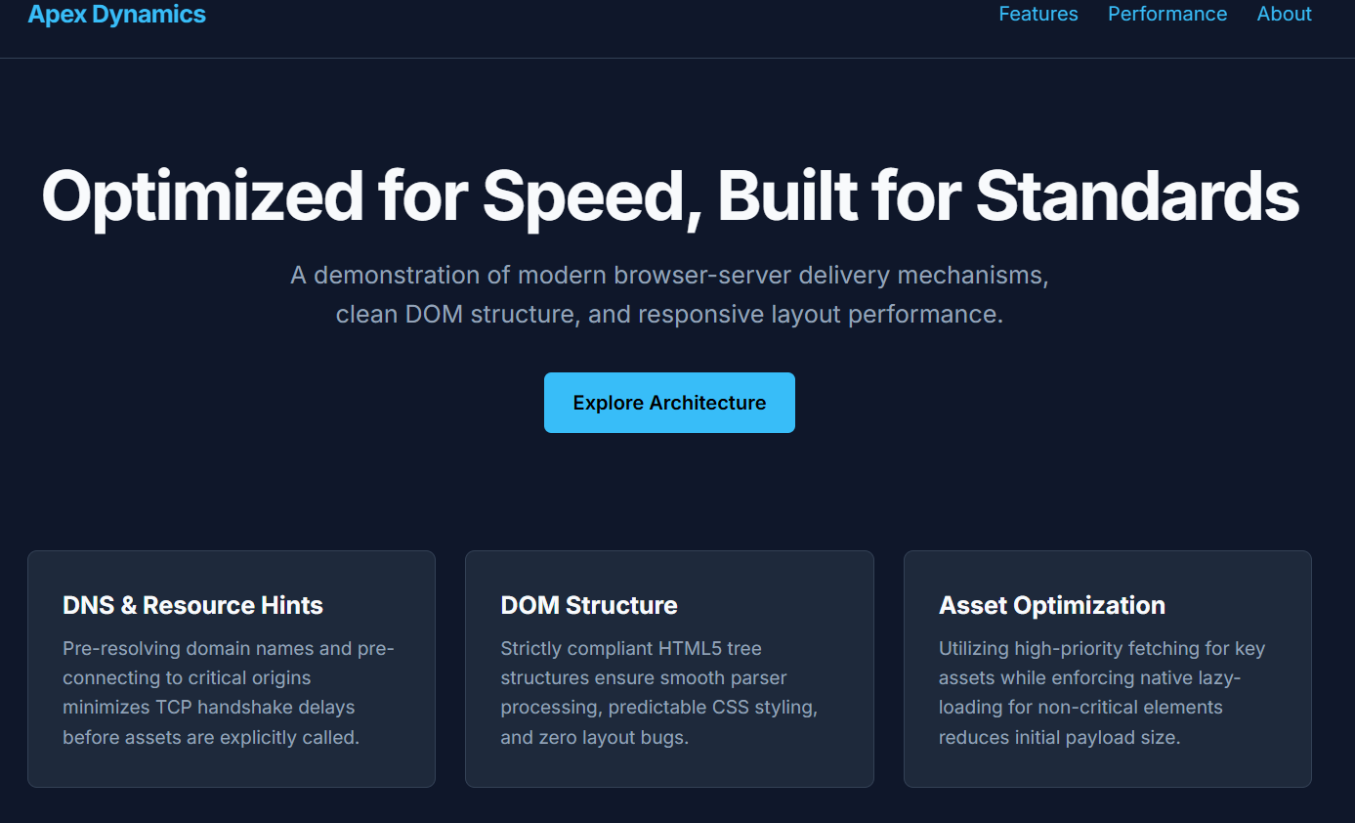
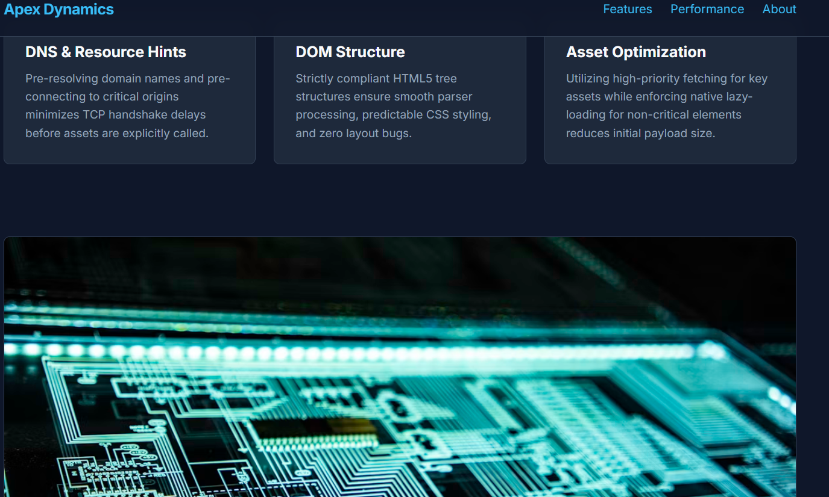
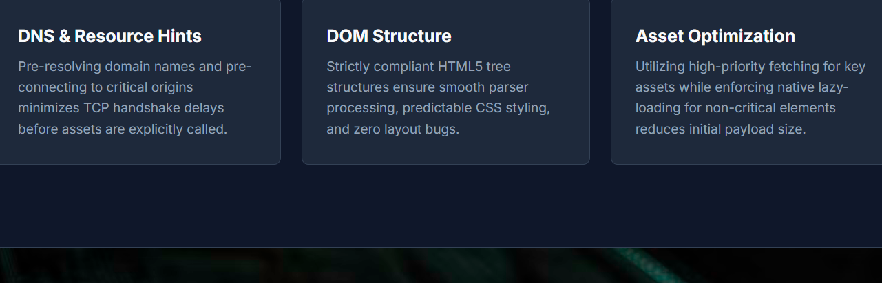

RUBRICS FOR CALCULATION:

Criteria | Weightage | Level 4 (Exemplary) | Level 3 (Proficient) | Level 2 (Developing) | Level 1 (Beginning)
Understanding of Data | 25% | Accurately interprets all data patterns, trends, and relationships | Interprets data correctly with minor gaps | Partial understanding; misses key trends | Misinterprets or fails to understand data
Analysis | 25% | Provides deep analysis with strong logical reasoning and justification | Provides reasonable analysis with some justification | Basic analysis with weak reasoning | No meaningful analysis provided
Application of Concepts | 20% | Effectively applies relevant concepts/tools to interpret data accurately | Applies concepts with minor errors | Limited application; requires guidance | Unable to apply concepts to data
Conclusion | 20% | Draws clear, meaningful conclusions with strong insights and implications | Provides valid conclusions with moderate insights | Conclusions are vague or weak | No clear or valid conclusions
Clarity | 10% | Presents interpretation clearly using proper structure, visuals, and terminology | Generally clear with minor issues | Lacks clarity or proper structure | Poor presentation and difficult to understand

